# Week1

Create a simple HTML program to display “This is my first HTML program”.

**PROGRAM:**

<!DOCTYPE html>

<html>

<head>

<title>First Program</title>

</head>

<body>This is my first program</body>

</html>



**PROBLEM STATEMENT:**

1. Create a HTML program to demonstrate all heading tags.

**PROGRAM:**

<!DOCTYPE html>

<html lang="en">

<head>

<meta charset="UTF-8">

<meta name="viewport" content="width=device-width, initial-scale=1.0">

<title>HEADINGS</title>

</head>

<body>

<h1>First</h1>

<h2>second</h2>

<h3>third</h3>

<h4>fourth</h4>

<h5>fifth</h5>

<h6>sixth</h6>

</body>

</html>

**OUTPUT:**

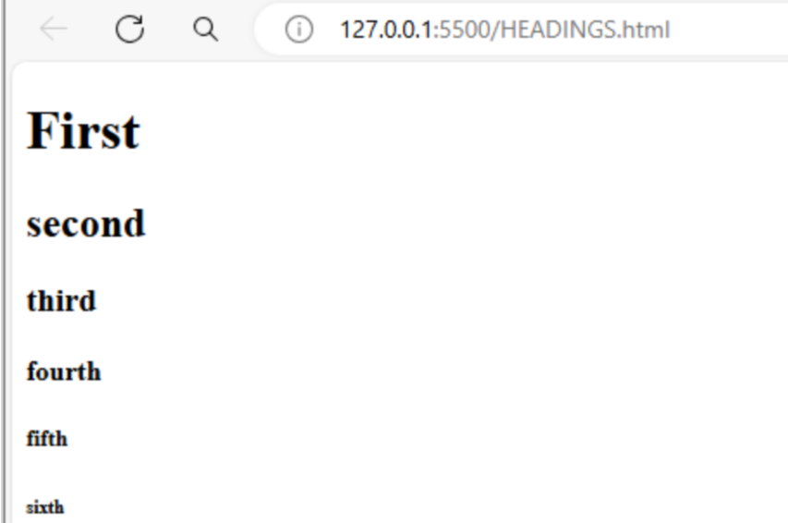

**PROBLEM STATEMENT:**

1. Create a HTML program to demonstrate all heading tags with alignment left,right and center.

**PROGRAM:**

<<!DOCTYPE html>

<html lang="en">

<head>

<meta charset="UTF-8">

<meta name="viewport" content="width=device-width, initial-scale=1.0">

<title>HEADINGS</title>

</head>

<body>

<h1 align=" center">First</h1>

<h2>second</h2>

<h3>third</h3>

<h4 align ="right">fourth</h4>

</body>

</html>



**PROBLEM STATEMENT:**

4. Create a HTML program to demonstrate the paragraph tag with alignment left,right,center and justify.

**PROGRAM:**

<!DOCTYPE html>

<html lang="en">

<head>

<meta charset="UTF-8">

<meta name="viewport" content="width=device-width, initial-scale=1.0">

<title>HEADINGS</title>

</head>

<body>

<p align ="center">hello world</p>

<p align ="left">fullstack</p>

<p align ="right">development</p>

</body>

</html>



**PROBLEM STATEMENT:**

5. Create a HTML program to demonstrate the without paragraph tag.

**PROGRAM:**

<!DOCTYPE html>

<html lang="en">

<head>

<meta charset="UTF-8">

<meta name="viewport" content="width=device-width, initial-scale=1.0">

<title>body</title>

</head>

<body>

HTML

PARA

ANCHOR

</body>

</html>



**PROBLEM STATEMENT:**

6. Create a HTML program to demonstrate the horizontal rule with attributes as color,size,width,align and noshade.

**PROGRAM:**

<!DOCTYPE html>

<html lang="en">

    <head>

<meta charset="UTF-8">

<meta name="viewport" content="width=device-width, initial-scale=1.0">

<title>HORIZINTAL</title>

</head>

<body>

<h1>HTML PAGE</h1>

<hr width="100%" size="2">

<hr width="100%" size="2" color="blue" noshade>

<hr width="100%;" color="red" size="5">

</body>

</html>



**PROBLEM STATEMENT:**

7. Create a HTML program to demonstrate line break and non breaking space.

**PROGRAM:**

<!DOCTYPE html>

<html lang="en">

<head>

<meta charset="UTF-8">

<meta name="viewport" content="width=device-width, initial-scale=1.0">

<title>Line Break and Non-breaking Space Example</title>

</head>

<body>

<p>This is the first line.<br>This is the second line with a line break.</p>

<p>This is&nbsp;a&nbsp;sentence</p>

</body>

</html>

# 

# Week 2

Create a simple HTML program to print the squares of the numbers from 1 to 10

**Program:-**

<!DOCTYPE html>

<html lang="en">

<head>

    <title>Document</title>

</head>

<body>

    the square of 1<sup>2</sup>=1<br>

    the square of 2<sup>2</sup>=4<br>

    the square of 3<sup>2</sup>=9<br>

    the square of 4<sup>2</sup>=16<br>

    the square of 5<sup>2</sup>=25<br>

    the square of 6<sup>2</sup>=36<br>

    the square of 7<sup>2</sup>=49<br>

    the square of 8<sup>2</sup>=64<br>

    the square of 9<sup>2</sup>=81<br>

    the square of 10<sup>2</sup>=100<br>

</body>

</html>

**Test Cases:**

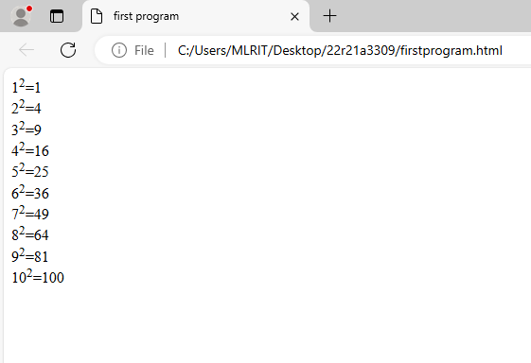

**Problem Statement-II** Create a HTML program to demonstrate ordered list

**Program:-**

<!DOCTYPE html>

<html lang="en">

<head>

    <meta charset="UTF-8">

    <meta name="viewport" content="width=device-width, initial-scale=1.0">

    <title>Document</title>

</head>

<body>

    <label>Names</label>

    <ol type="1" first=”4”>

        <li>harshitha</li>

        <li>nikitha</li>

        <li>srinidhi</li>

    </ol>

</body>

</html>

**Test Cases:**

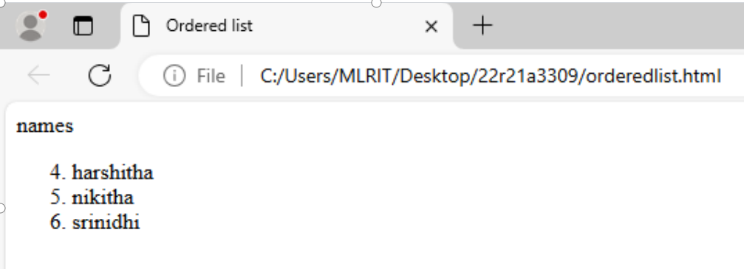

**Problem Statement-III:** Create a HTML program to demonstrate description list

**Program:-**

<!DOCTYPE html>

<html lang="en">

<head>

    <meta charset="UTF-8">

    <meta name="viewport" content="width=device-width, initial-scale=1.0">

    <title>Document</title>

</head>

<body>

    <dl>

        <dt>java</dt>

        <dd>object oriented programming</dd>

        <dt>python</dt>

        <dd>structed language</dd>

    </dl>

</body>

</html>

**Test Cases:**

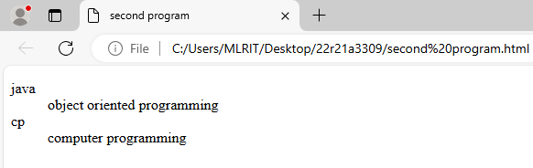

**Problem Statement-IV:** Create a HTML program to demonstrate the following tags

a)acronym b)address c)blockquote

**Program:-**

<!DOCTYPE html>

<html lang="en">

<head>

    <meta charset="UTF-8">

    <meta name="viewport" content="width=device-width, initial-scale=1.0">

    <title>Document</title>

</head>

<body>

    Welcome to <acronym title="computer science and information technology">CSIT</acronym>

    <address>this is harshitha</address>

    <blockquote>Welcome to html</blockquote>

</body>

</html>

**Test Cases:**

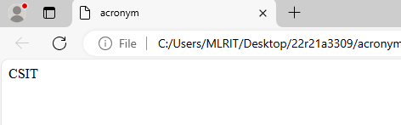

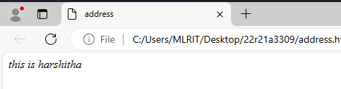

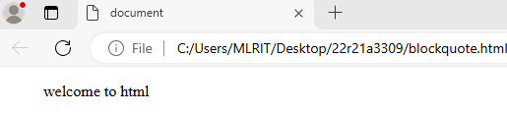

**Problem Statement-V:** Create a HTML program to demonstrate the following tags

a)pre b)<s>,<del>,<strike> c)<q>

**Program:-**

<!DOCTYPE html>

<html lang="en">

<head>

    <meta charset="UTF-8">

    <meta name="viewport" content="width=device-width, initial-scale=1.0">

    <title>Document</title>

</head>

<body>

    <pre>this is pre tag

    </pre>

    <del>this is del tag</del><br>

    <s>this is s tag</s>

    <strike>this is stike tag</strike><br>

<q>this is q tag</q>

</body>

</html>

**Test Cases:**

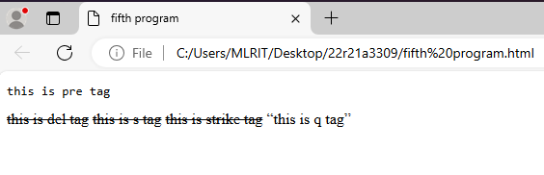

Write a HTML program to display image of “national flag”and apply attributes of the image.

**Program:-**

<!DOCTYPE html>

<html lang="en">

<head>

<title>National Flag</title>

</head>

<body>

<img src="C:\Users\MLRIT\Desktop\3304\images.png" alt="image not found" align="left" border="10px" width="1000px" height="1000px" vspace="100px" hspace="100px">

</body>

</html>

**Test Cases:**

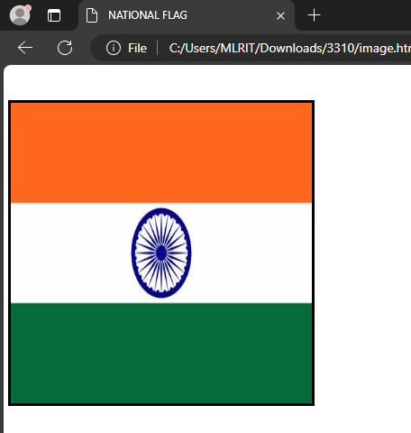

**Problem Statement-II** Write a HTML program for the demonstration of unordered list.

**Program:-**

<!DOCTYPE html>

<html lang="en">

<head>

<title>Document</title>

</head>

<body>

<label>cricket</label>

<ul>

<li>rohit</li>

<li>virat</li>

<li>shikhar</li>

<li>bumrah</li>

</ul>

</body>

</html>

**Test Cases:**

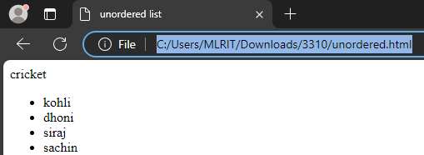

**Problem Statement-III:** Write a HTML for the demonstration of nested list.

**Program:-**

<!DOCTYPE html>

<html lang="en">

<head>

<title>nested list</title>

</head>

<body>

<label>bikes</label>

<ol type="1" start="5">

<li>pulsar</li>

<li>java</li>

<ul>

<li>42 bobber</li>

<li>classic</li>

<li>yezdi</li>

</ul>

<li>royal enfield</li>

</ol>

</body>

</html>

**Test Cases:**

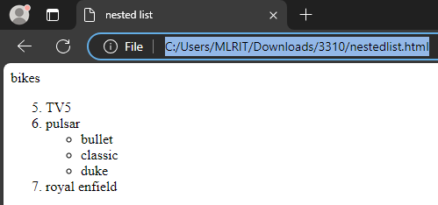

**Problem Statement-IV:** Write a HTML program for the demonstration of following tags.

a><dfn> b><mark> c><ins>.

**Program:-**

<!DOCTYPE html>

<html lang="en">

<head>

<title>Tags</title>

</head>

<body>

<dfn>CSIT</dfn>computer science and infrmation technology<br>

hello <mark>world</mark>

this is my <ins>webpage</ins>

</body>

</html>

**Test Cases:**

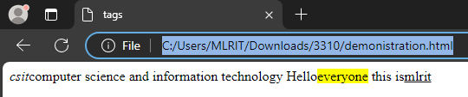

**Problem Statement-V:** Write a HTML program for the demonstration of following tags.

a><pre> b><del>,<s>,<strike> c><q>.

**Program:-**

<!DOCTYPE html>

<html lang="en">

<head>

<title>tags</title>

</head>

<body>

<pre>

hi everyone

this is rahul

rom CSIT

</pre>

this is <del>mlr</del><br>

how are <s>you</s><br>

i am from <strike>csit</strike><br>

<q>this is my college</q>

</body>

</html>

**Test Cases:**

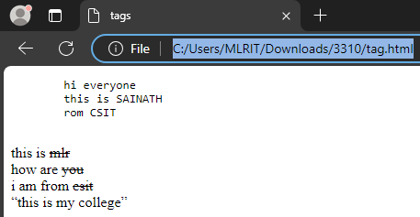

# Week3

**PROBLEM STATEMENT:**

1. a) Write a HTML program for demonstrating Hyperlinks.

i. Navigation from one page to another. ii. Navigation within the page.

**PROGRAM:**

**a.** <!DOCTYPE html>

<html lang="en">

<head>

<meta charset="UTF-8">

<meta name="viewport" content="width=device-width, initial-scale=1.0">

<title>internal</title>

</head>

<body>

<a href="https://www.geeksforgeeks.org/" title="click on me">geeksforgeeks</a>

</body>

</html>

**b.** <!DOCTYPE html>

<html lang="en">

<head>

<meta charset="UTF-8">

<meta name="viewport" content="width=device-width, initial-scale=1.0">

<title>external</title>

</head>

<body>

<a href="https://www.geeksforgeeks.org/" title="click on me" target="_blank">geeksforgeeks</a>

</body>

</html>

**OUTPUT:**

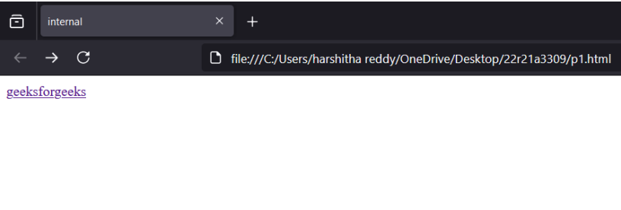

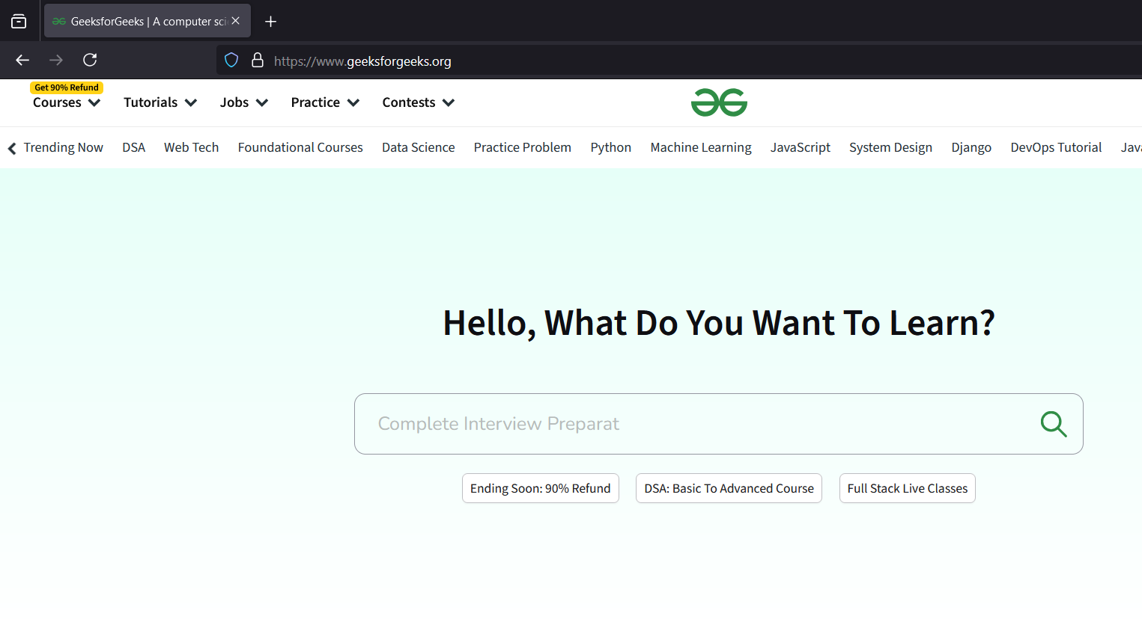

**PROBLEM STATEMENT:**

2. Write a HTML program to demonstrate <div> tag



**PROGRAM:** <!DOCTYPE html>

<html lang="en">

<head>

<meta charset="UTF-8">

<meta name="viewport" content="width=device-width, initial-scale=1.0">

<title>Flag</title>

</head>

<body>

<div align="left" style="background-color: orange;height: 100px;width: 100%;">

</div>

<div align="center" style="background-color: white;height: 100px;width: 100%;">

<img src="ashokachakra.webp" width="100px">

</div>

<div align="right" style="background-color: green;height: 100px;width: 100%;">

</div>

</body>

</html>

**OUTPUT:**

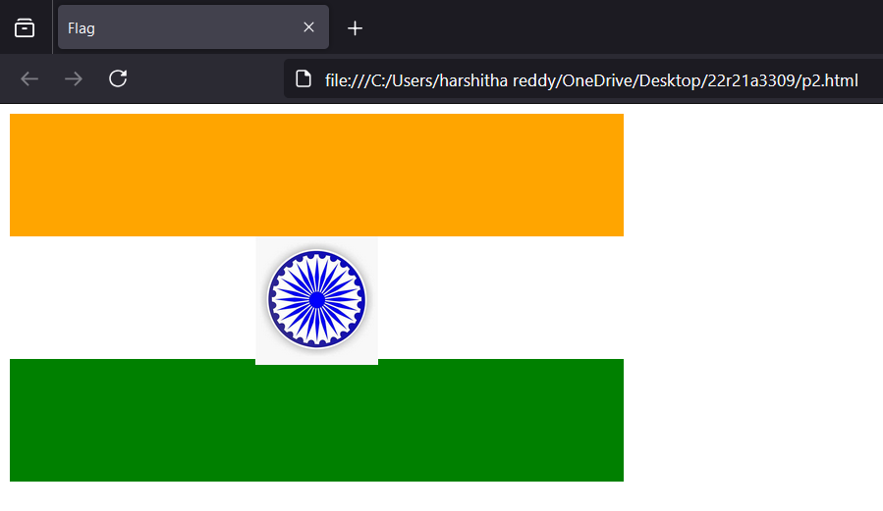

**PROBLEM STATEMENT:**

3. Write a HTML Page to create a Student registration form that collects various student information such as first name, last name, Roll No., email id, mobile number, etc and a two buttons: submit and reset.

**PROGRAM:**

<!DOCTYPE html>

<html lang="en">

<head>

<meta charset="UTF-8">

<meta name="viewport" content="width=device-width, initial-scale=1.0">

<title>Registration</title>

</head>

<body>

<form>

<label>Firstname</label>

<input type="text"><br>

<label>Lastname</label>

<input type="text"><br>

<label>Rollno</label>

<input type="text"><br>

<label>Email</label>

<input type="text"><br>

<label>Phoneno</label>

<input type="text"><br>

<input type="submit"><input type="reset">

</form>

</body>

</html>

**OUTPUT:**

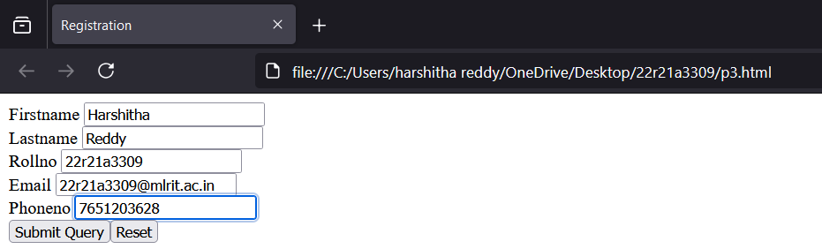

**PROBLEM STATEMENT:**

4. Write a HTML program to demonstrate form tag

i)

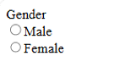

ii)

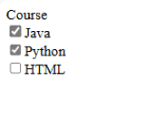

**PROGRAM:**

i) <!DOCTYPE html>

<html lang="en">

<head>

<meta charset="UTF-8">

<meta name="viewport" content="width=device-width, initial-scale=1.0">

<title>Gender</title>

</head>

<body>

<label>Gender</label><br>

<input type="radio">Male<br>

<input type="radio">Female<br>

</body>

</html>

ii) <!DOCTYPE html>

<html lang="en">

<head>

<meta charset="UTF-8">

<meta name="viewport" content="width=device-width, initial-scale=1.0">

<title>Course</title>

</head>

<body>

<label>Course name:</label><br>

<input type="checkbox" name="Course">Java<br>

<input type="checkbox" name="Course">DBMS<br>

<input type="checkbox" name="Course">DS

</body>

</html>

**OUTPUT:**

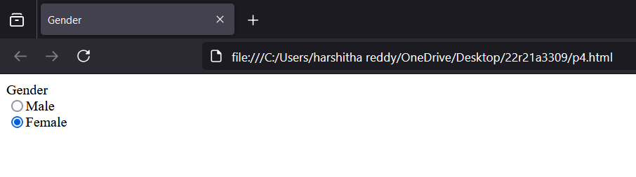

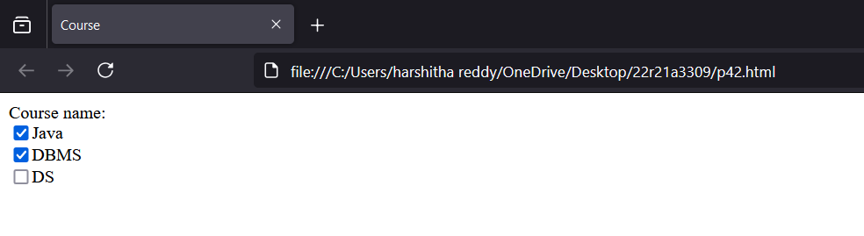

**PROBLEM STATEMENT:**

5.Write a HTML program to demonstrate form tag

i)

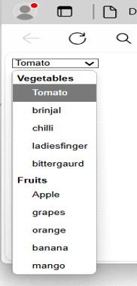

ii)

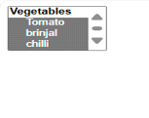

iii)



**PROGRAM:**

i) <!DOCTYPE html>

<html lang="en">

<head>

<meta charset="UTF-8">

<meta name="viewport" content="width=device-width, initial-scale=1.0">

<title>Vegetables</title>

</head>

<body>

<form>

<select>

<optgroup label="Vegetables">

<option>Carrot</option>

<option>Tomato</option>

<option>Brinjal</option>

<option>Onion</option>

<option>Cauliflower</option>

</optgroup>

<optgroup label="Fruits">

<option>Apple</option>

<option>Banana</option>

<option>Mango</option>

</optgroup>

</select>

</form>

</body>

</html>

ii)<!DOCTYPE html>

<html lang="en">

<head>

<meta charset="UTF-8">

<meta name="viewport" content="width=device-width, initial-scale=1.0">

<title>Vegetables</title>

</head>

<body>

<select multiple="multiple">

<optgroup label="Vegetables">

<option>Carrot</option>

<option>Tomato</option>

<option>Brinjal</option>

<option>Onion</option>

<option>Cauliflower</option>

</optgroup>

</select>

</body>

</html>

iii) <!DOCTYPE html>

<html lang="en">

<head>

<meta charset="UTF-8">

<meta name="viewport" content="width=device-width, initial-scale=1.0">

<title>Cars</title>

</head>

<body>

<form>

<fieldset>

<legend>Cars</legend>

<input type="checkbox">Benz

<input type="checkbox">Swift

<input type="checkbox">Honda

<input type="checkbox">Porsche

</fieldset>

</form>

</body>

</html>

**OUTPUT:**

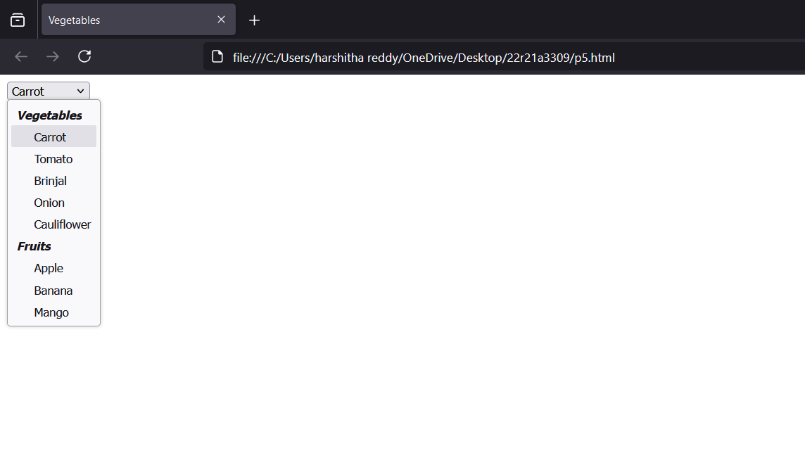

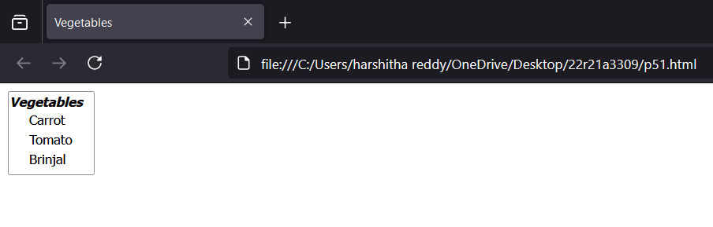

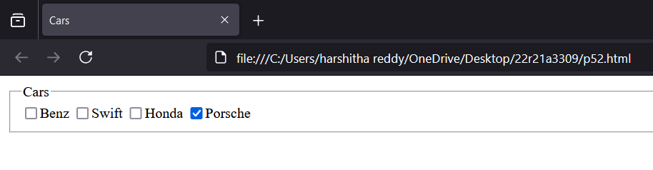

**PROBLEM STATEMENT:** 6. Write a HTML Page to create a User registration form that collects various information such as Username, Password, and a two buttons: submit and reset and perform below operations

i) Action attribute

action link to [**https://www.youtube.com/@thulasichitra4932**](https://www.youtube.com/@thulasichitra4932)

ii) method attribute with get and post

**PROGRAM:**

i) <!DOCTYPE html>

<html lang="en">

<head>

<meta charset="UTF-8">

<meta name="viewport" content="width=device-width, initial-scale=1.0">

<title>link</title>

</head>

<body>

<form action="https://www.youtube.com/@thulasichitra4932">

<label>Username</label>

<input type="text"><br>

<label>Password</label>

<input type="password"><br>

<input type="submit"> <input type="reset">

</form>

</body>

</html>

ii) <!DOCTYPE html>

<html lang="en">

<head>

<meta charset="UTF-8">

<meta name="viewport" content="width=device-width, initial-scale=1.0">

<title>Document</title>

</head>

<body>

<form method="post">

<label>Username</label>

<input type="text"><br>

<label>Password</label>

<input type="password"><br>

<input type="submit"> <input type="reset">

</form>

</body>

</html>

**OUTPUT:**

**i)**

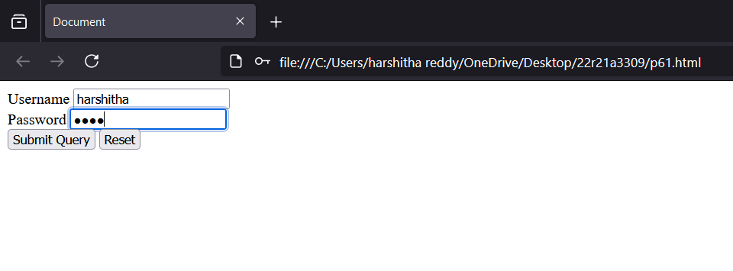

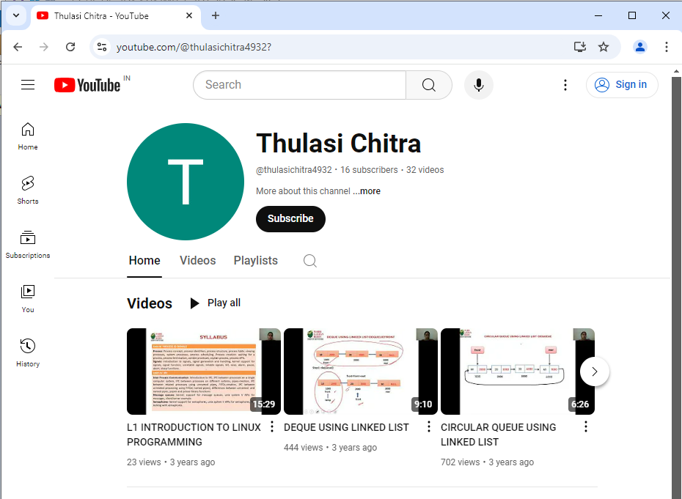

ii)

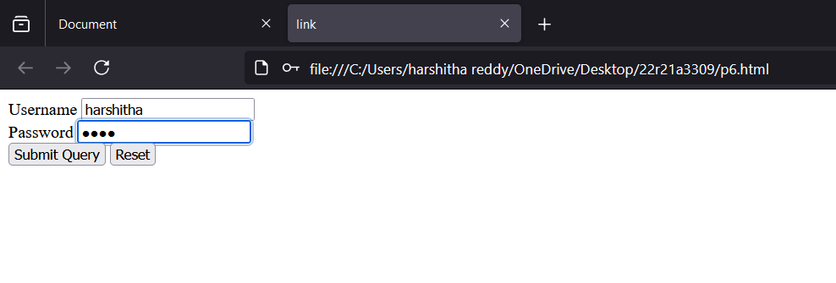

# Week 5

<!DOCTYPE html>

<html lang="en">

<head>

<meta charset="UTF-8">

<meta name="viewport" content="width=device-width, initial-scale=1.0">

<title>Layout</title>

<link rel="stylesheet" href="ps1.css">

</head>

<body>

<div id="container">

<div id="header"></div>

<div id="left"></div>

<div id="middle"></div>

<div id="right"></div>

<div id="footer"></div>

</div>

</body>

</html>

**CSS**

div{

margin: 10px;

}

#header{

background-color: gray;

height: 50px;

width: 840px;

}

#footer{

background-color: green;

height: 50px;

width: 840px;

clear:left;

}

#left{

background-color: blue;

height: 300px;

width: 100px;

float:left;

}

#middle{

background-color: red;

height: 300px;

width: 600px;

float:left;

}

#right{

background-color: black;

height: 300px;

width: 100px;

float:left;

}

**2)**<!DOCTYPE html>

<html lang="en">

<head>

<meta charset="UTF-8">

<meta name="viewport" content="width=device-width, initial-scale=1.0">

<title>CSS Box Model Example</title>

<link rel="stylesheet" href="ps2.css">

</head>

<body>

<h1>CSS Box-Model Property</h1>

<div class="container">

<div class="title">MLRIT</div>

<div class="subtitle">A best Engineering College</div>

</div>

</body>

</html>

**css**

body {

text-align: center;

}

.container {

margin: 50px auto;

padding: 50px;

border: 20px solid purple;

width: 500px;

background-color: white;

}

.title {

font-size: 24px;

background-color: purple;

font-weight: bold;

}

.subtitle {

font-size: 18px;

margin-top: 10px;

}

**3)**!DOCTYPE html>

<html lang="en">

<head>

<meta charset="UTF-8">

<meta name="viewport" content="width=device-width, initial-scale=1.0">

<title>FlexLayout</title>

<link rel="stylesheet" href="flex.css">

</head>

<body>

<h1 style="text-align: center;">Grid of items</h1>

<div class="container">

<div class="f1">1</div>

<div class="f1">2</div>

<div class="f1">3</div>

<div class="f1">4</div>

<div class="f1">5</div>

<div class="f1">6</div>

<div class="f1">7</div>

<div class="f1">8</div>

<div class="f1">9</div>

</div>

</body>

</html>

**CSS**

.container{

display: grid;

grid-template-columns: 180px 180px 180px;

grid-template-rows: 50px 50px 50px;

grid-gap: 3px;

background-color: rgb(106, 98, 98);

padding: 2px;

height: 157px;

width: 547px;

}

.f1{

background-color: rgb(223, 217, 217);

text-align: center;

font-size: 20px;

padding: 15px;

}

**4)**<!DOCTYPE html>

<html lang="en">

<head>

<meta charset="UTF-8">

<meta name="viewport" content="width=device-width, initial-scale=1.0">

<title>FlexLayout</title>

<link rel="stylesheet" href="grid.css">

</head>

<body>

<h1 style="text-align: center;">Flex of items</h1>

<div class="container">

<div class="f1">1</div>

<div class="f1">2</div>

<div class="f1">3</div>

<div class="f1">4</div>

<div class="f1">5</div>

<div class="f1">6</div>

<div class="f1">7</div>

<div class="f1">8</div>

<div class="f1">9</div>

</div>

</body>

</html>

**CSS**

.container{

display:flex;

grid-gap:2px;

background-color: skyblue;

padding: 2px;

}

.f1{

background-color: pink;

text-align: center;

font-size: 20px;

padding:1cqh;

height: 20px;

}

**5)** <!DOCTYPE html>

<html lang="en">

<head>

<meta charset="UTF-8">

<meta name="viewport" content="width=device-width, initial-scale=1.0">

<title>Flex Layout</title>

<link rel="stylesheet" href="flex.css">

</head>

<body>

<h2 style="text-align: center;">Welcome to MLRIT</h2>

<div class="container">

<div class="f1">1</div>

<div class="f1">2</div>

<div class="f1">3</div>

<div class="f1">4</div>

<div class="f1">5</div>

<div class="f1">6</div>

<div class="f1">7</div>

<div class="f1">8</div>

<div class="f1">9</div>

</div>

</body>

</html>

**CSS**

.container{

display: grid;

grid-template-columns: 100px 100px 100px;

grid-template-rows: 50px 50px 50px;

grid-gap: 10px;

background-color: green;

padding: 10px;

height: 175px;

width: 325px;

}

.f1{

background-color: orange;

text-align: center;

font-size: 20px;

padding: 15px;

}

Week 4

1.The first frame must have a table that has two levels of column labels: an overall label Meals, and three Secondary labels, Breakfast, Lunch and Dinner. There must be two levels of row labels: an overall label, Foods, and four secondary labels, Bread, Main Course, Vegetable, and dessert. The cells of the table must contain a number of grams for each of the food categories.

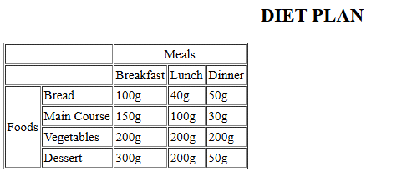

PROGRAM:

<!DOCTYPE html>

<html lang="en">

<head>

<meta charset="UTF-8">

<meta name="viewport" content="width=device-width, initial-scale=1.0">

<title>Document</title>

</head>

<body>

<table border="">

<tr>

<td colspan="3"></td>

<td colspan="3">meals</td>

</tr>

<tr>

<td colspan="3"></td>

<td>breakfast</td>

<td>lunch</td>

<td>dinner</td>

</tr>

<tr>

<td rowspan="5">foods</td>

<td colspan="2">bread</td>

<td>100g</td>

<td>40g</td>

<td>50g</td>

</tr>

<tr>

<td colspan="2">Main course</td>

<td>150g</td>

<td>100g</td>

<td>30g</td>

</tr>

<tr>

<td colspan="2">Vegetables</td>

<td>200g</td>

<td>200g</td>

<td>200g</td>

</tr>

<tr>

<td colspan="2">Dessert</td>

<td>300g</td>

<td>200g</td>

<td>50g</td>

</tr>

</table>

</body>

</html>

**OUTPUT:**

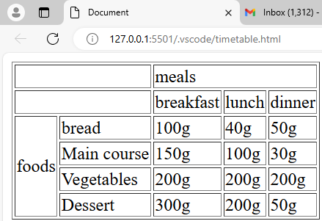

**PROBLEM STATEMENT:**

2.Write a HTML program to create a web page which displays image table as shown in below image:

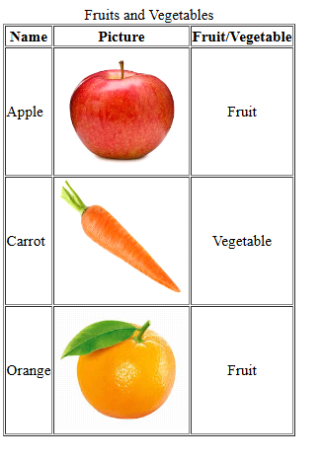

PROGRAM:

<!DOCTYPE html>

<html lang="en">

<head>

<meta charset="UTF-8">

<meta name="viewport" content="width=device-width, initial-scale=1.0">

<title>Document</title>

</head>

<body>

<table border="">

<tr>

<td>name</td>

<td>picture</td>

<td>friut/vegitable</td> </tr>

<tr>

<td>apple</td>

<td><img src="apple.jfif" alt=""></td>

<td>friut</td> </tr>

<tr>

<td>carrot</td>

<td><img src="carrot.jfif" alt=""></td>

<td>vegetable</td> </tr>

<tr>

<td>orange</td>

<td><img src="orange.jfif" alt=""></td>

<td>Friut</td>

</tr>

</table>

</body>

</html>

***OUTPUT:***

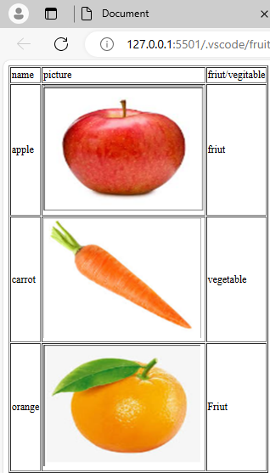

**PROBLEM STATEMENT:**

3. Write a HTML program to create a web page which displays a video and image in two different frames as shown in below image:

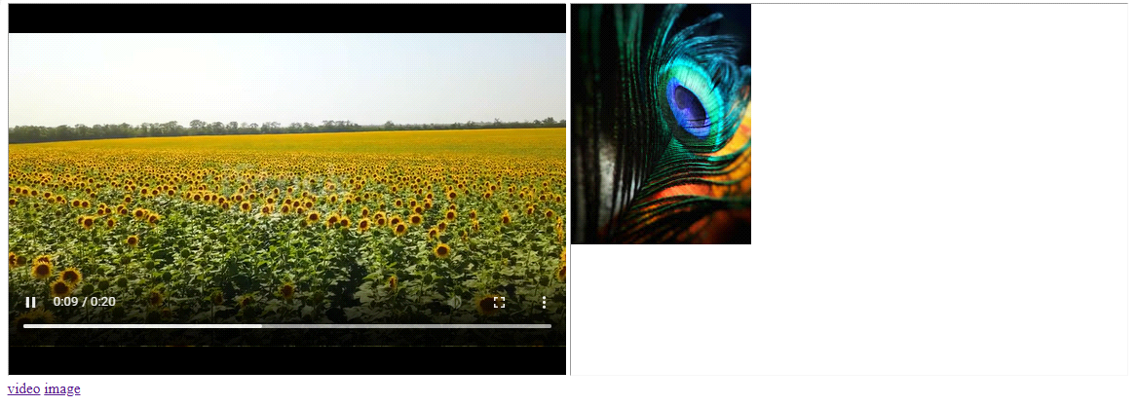

**PROGRAM:**

<!DOCTYPE html>

<html lang="en">

<head>

<meta charset="UTF-8">

<meta name="viewport" content="width=device-width, initial-scale=1.0">

<title>Document</title>

</head>

<body>

<iframe name="myframe" frameborder="0">

</iframe>

<iframe src="image.jfif" frameborder="0"></iframe><br>

<a href="video.mp4" target="myframe">videolink</a>

</body>

</html>

**OUTPUT:**

